Xbox Controller:
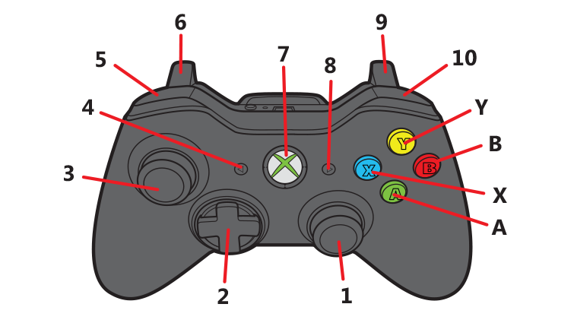
Prep for Amp Shot (straight down)
Prep for far shot
Overhead shot prep
Prep for close shot
Shoot
N/A
Up: Prep for long pass
Down: Prep for short pass
Left:
Right:
Small Shot (hold = prep)
When pressed: manual arm control
Reverse intake
N/A
Stop motors
Intake Piece
Prep for “Amp Shot” (down)

Stow wrist

Joysticks:




N/A
Shoot Piece
N/A
N/A

Copanel:
Prep for climb
Climb
DO NOT USE

Nudge Wrist Up

Nudge Wrist Down

Nudge Amp Shot Up
Reset Rotation

Nudge Amp Shot Down

Connect XBox controller

